Book title: Rhyming Dust Bunnies
Author: Jan Thomas

Supplies for activities needed:
- Markers
- Pencil
- Worksheet Attached
- Googly Eyes
- Glue
Activity Name:
- School Readiness Outcomes (SRO) goals met:
  - Producing a rhyme if words are offered.
  - Experimenting with a growing variety of writing tools and materials.
  - Recognizing Rhymes
- Instructions
- Fill in the speech bubble with a word that rhymes with hat
- Draw a dust bunny under the speech bubble
- Glue googly eyes onto the dust bunny

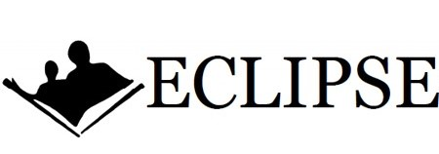

What Rhymes With Cat?

